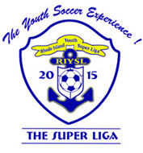
The super liga sportsmanship card

The Super Liga’s philosophy is to provide a fun filled and safe environment to create the “Youth Soccer Experience”.
Positive and enthusiastic feedback from all that are involved with this game is encouraged.
To accomplish this, the Super Liga’s expectations is that coaches, players, referees and spectators respect each other and the game. Negative or threatening statements from anyone will not be tolerated. If such statements or actions occur, the referee will deal with each situation according to the Super Liga rules and policies. It is the referee's discretion to terminate the game without warning if he/she feels there has been a threat made to the referee crew, players and/or coaches. Any spectator that enters the field of play without permission or discretion of the referee will force the referee to terminate the game immediately.
PLAY FAIR !! PLAY WELL !!

The Super Liga Sportsmanship Card
- This Card is to be read to all coaches, players and spectators, after the players and coaches are checked in, near the spectator side of the field.
- Check off on the game report, “Card Read”.

Super liga General Information
- Website: www.thesuperliga.com
- Hot Line: 401-253-0168
Mailing address: RIYSL, PO Box 467, Bristol, RI 02809

